**Path Visualization by Scatter Histogram Library in Open Field Test .CSV Files**

# Introduction

A scatter histogram is a type of graph that is used to visualize the movement patterns of animals in an open field test. It is often used in behavioral neuroscience research to study the behavior of mice or other small animals in a controlled environment. In an open field test, mice or other animals are placed in a large, open arena and their movements are tracked over a set period of time. The scatter histogram is a graphical representation of the path that the animals take as they move around the arena. It shows the density of the animal's movements (or presence) at different points (based on x and y) in the determined positions, allowing researchers to see how the animals are exploring the space and whether their movements are random or directed. The scatter histogram is often used in conjunction with other tools, such as heat maps and trajectory plots, to provide a more detailed understanding of the animals' movements and behaviors. By analyzing the scatter histogram and other data from the open field test, researchers can learn more about the animals' natural behaviors, their responses to different stimuli, and their overall level of activity.

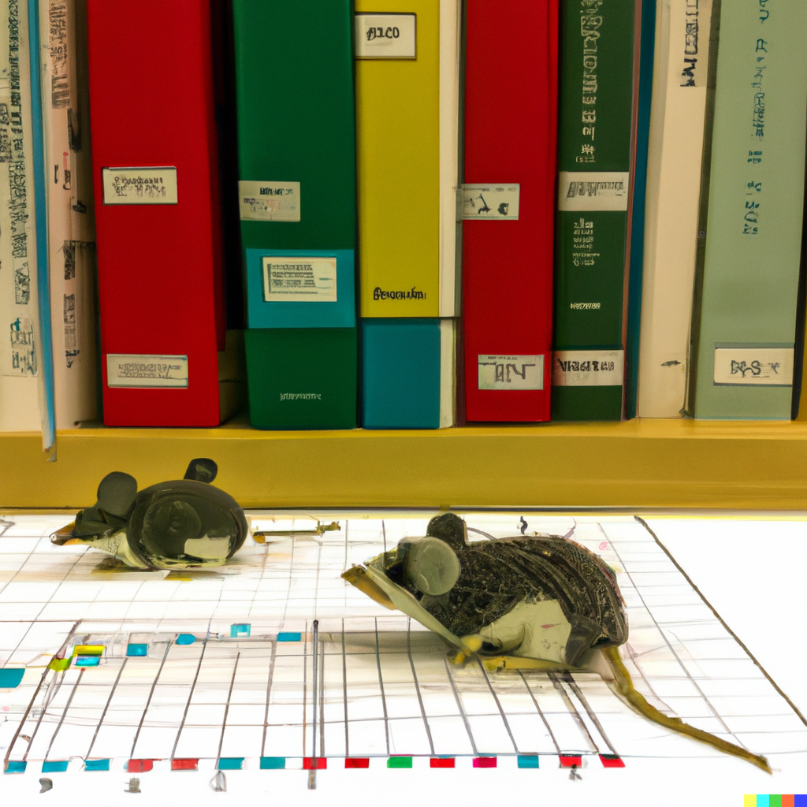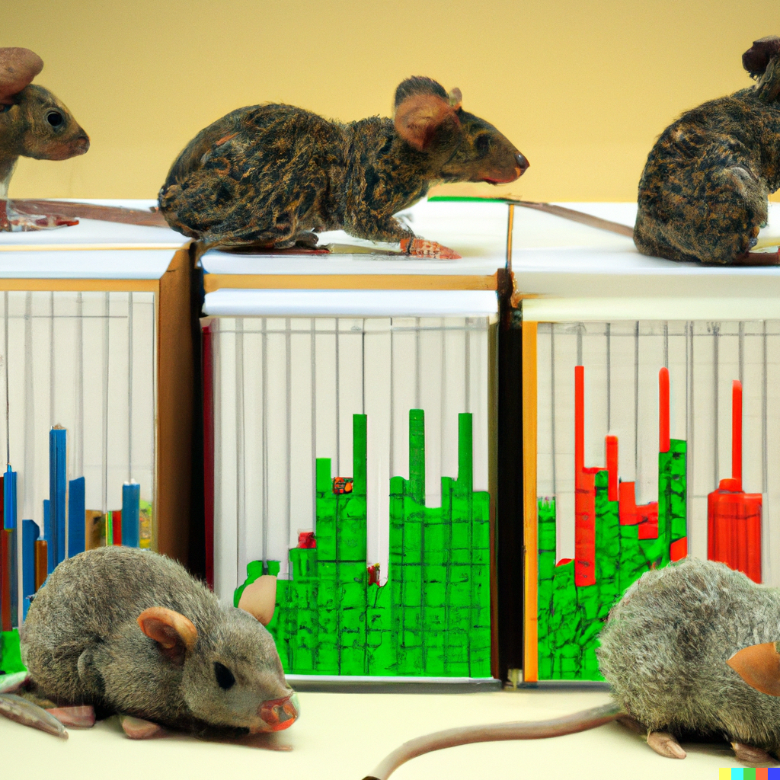

# How this code helps

This code creates a scatter plot and a histogram of the x and y data from a CSV file. It reads in the data from the file example.csv using the read_csv function from the pandas library, and then extracts the x and y values from the DataFrame using the values attribute. The code also defines a mapping from string values in the ROI_location column to integer values, and uses the map function to convert the string values to integers. It then creates a colormap using the ScalarMappable function from the matplotlib.cm module, and uses it to map the integer values to colors. Finally, the code creates a scatterplot using the scatter function, and adds histograms to the top and right axes using the hist function. It removes the tick marks from the histograms, and sets the yticks and xticks of the histograms to specific values. The code then saves the plot as a JPEG image with a DPI of 600 using the savefig function, and displays the plot using the show function.

Also for more detail, it should be mentioned that the axHistx and axHisty variables refer to two axes objects that are created as part of a scatter plot. The axHistx axis is intended to display a histogram of the x values and the axHisty axis is intended to display a histogram of the y values in open field test. These histograms show the frequency of occurrence of the x and y values, respectively. The code creates a scatter plot using the x and y values, with different colors for the points based on the values of the z array. It worth to mention that z is the same data which is representing region of interest (which is called ROI_location). Open field test has been comprised following parts in which c and b represents corner and border ('c1', 'c2', 'c3', 'c4', 'b1', 'b2', 'b3', 'b4', 'center','b1_center', 'b2_center', 'b3_center', 'b4_center', 'c1_b1', 'c1_b4', 'c4_b4', 'c4_b3', 'c3_b3', 'c3_b2', 'c2_b2', 'c2_b1'). Then, it creates two additional axes objects, axHistx and axHisty, which are positioned above and to the right of the scatter plot, respectively. These axes are used to display histograms of the x and y values using the hist function. The axHistx histogram shows the frequency of occurrence of the x values, and the axHisty histogram shows the frequency of occurrence of the y values.



**Figure 2:** A represents the csv file example and B is for example_1 csv file in the the open field test areas and star is the first place that animal has been placed in the box for measuring its related behavior. As you can see axis X and Y has been representing 2 bar for corner, border positions and 4 bars (in the middle) are the frequencies of the animal presence at that special point either for border and center. This Histograms representing the animal x and y points occurrence with in the 5-min test and this illustrates animals x and y in different positions in term of corner, border and center position.

# Conclusion

EZ The open field test is a behavioral test used to measure animal behavior in a defined area. In this study, two CSV files (A and B) were used to record the movement and behavior of an animal in an open field test. The animal was initially placed at a designated starting point (indicated by the star) and its behavior was recorded over a 5-minute test period. The X and Y axes of the histograms represent the different positions of the animal within the test area, with two bars representing the corner positions and four bars representing the border and center positions. The histograms show the frequencies of the animal's presence at these different positions, indicating how often the animal was located in the corner, border, or center of the test area. In the end, these histograms illustrate the movement and behavior of the animal in the open field test, showing the animal's presence at different x and y positions within the test area. This information can be used to understand the animal's behavior and movements in the defined test area for checking memory, stress and anxiety related behavior. If you find this topic interesting and would like to learn more, I would be glad to discuss it in more detail.